EC Declaration of Performance

Lime Green Product Ltd
Coates Kilns
Stretton Road
Much Wenlock
TF13 6DG

Declares that the product Lime Green Ashlar Mortar, described in the product datasheet, is manufactured at the above address, has undergone relevant Initial Type Testing and complies with the requirements of annexe ZA1 of EN BS 998:2 2010.
Lime Green Ashlar Mortar is made under Factory Production Control at the above address according to Annexe ZA2 of EN BS 998 -2 and complies with the requirements of CE marking.

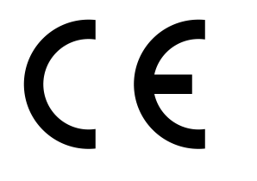
Lime Green Products Ltd
Coates Kilns, Stretton Road, Much Wenlock, TF13 6DG

13

EN 998–2

Prescribed General Purpose masonry mortar for external use

Proportion of Constituents (by volume):
Natural Hydraulic Lime: 1 Part
Aggregates: 2 Parts
Contents of chloride: NPD
Water absorption: 1.5 kg/(m².min^{0.5})
Water vapour permeability: μ 5 / 20
Reaction to fire: Class A1
Thermal Conductivity: (λ10,dry) P =50%: 0.47 W/mK
P =90%: 0.54 W/mK
Durability (against freeze-thaw): evaluation based on provisions valid in the intended place of use of the mortar.
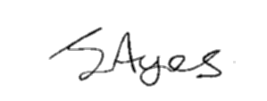

Signed:

Name: James Ayres
Position: Director
Date: 22/2/2013

